

**Plus much much more…..**

**Celebrate** **World Space Week 2019**

**with the Wells and Mendip Astronomers**





**Free Entry**

Space Detectives Virtual Reality

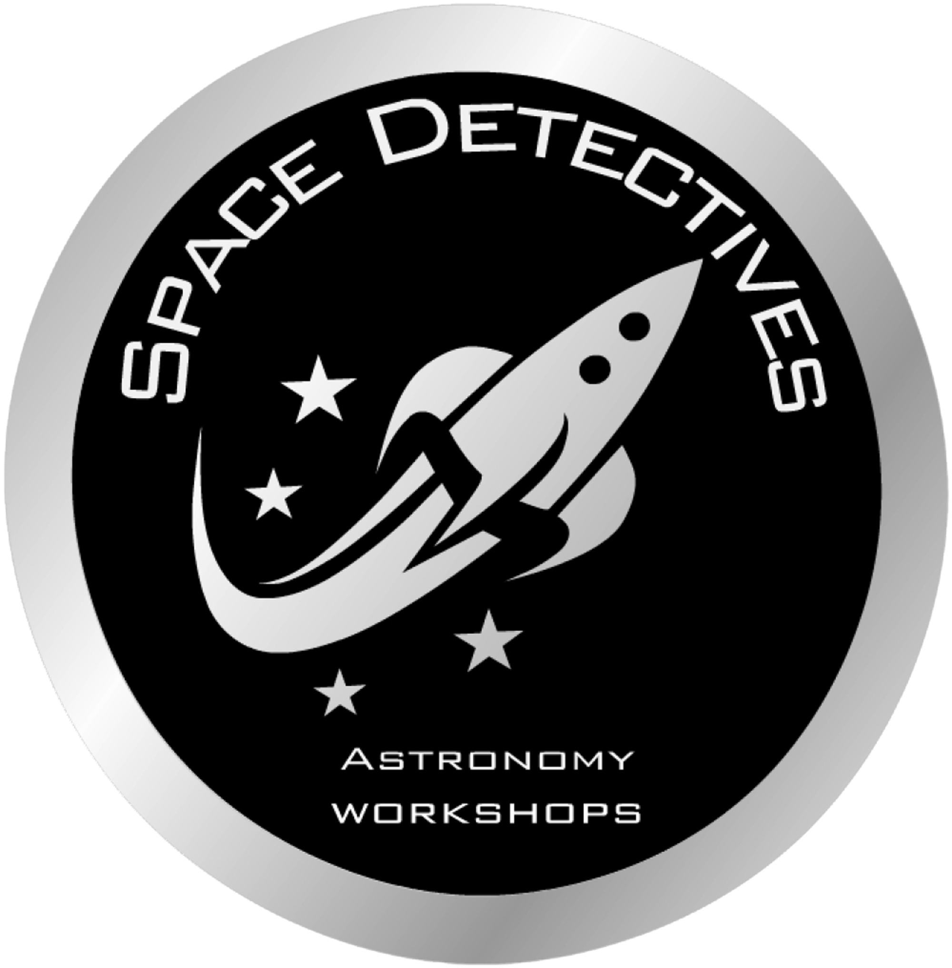

Build and Launch your own Rocket

Learn about Astrophotography

Control a robotic Mars Rover

Space Displays and Information

3D Space Printing

Spectroscopy

**Wells Library**

**Saturday 5th October 2019 10am – 2pm**